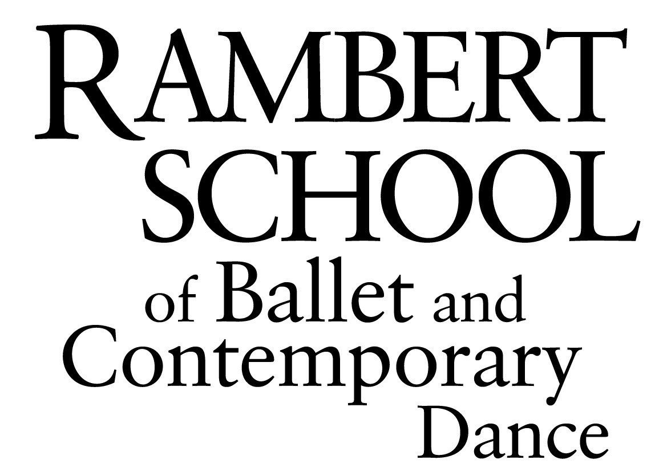
Director: Ross McKim MA, PhD, NBS (IDP) Patrons: Lady Anya Sainsbury CBE, Robert Cohan CBE

PLEASE ATTACH A RECENT PASSPORT SIZE PHOTOGRAPH

(This photograph will be used for identification purposes only, and does not form part of the selection process)

Clifton Lodge
St. Margaret’s Drive
Twickenham
Middlesex
TW1 1QN

Phone: 020 8892 9960
Fax: 020 8892 8090
Email: info@rambertschool.org.uk

Application form for entry in September 2011
Foundation Degree / BA (Hons) in Ballet & Contemporary Dance - 3 year course
validated by University of Kent

Please complete all sections and return your completed application to the above address with:
· a non-refundable administrative fee of 20,000JPN
· all requested photos

Have you applied to the Rambert School in the past? □ Yes □ No If yes, for which year __________________

Are you transferring from another Higher Education Institution? □ Yes □ No

PERSONAL DETAILS

Title (please tick one) □ Mr. □ Mrs. □ Miss □ Ms. □ Other ____________
名字 | 名前
住所 〒  ______________________________________________________  ______________________________________________________ | 郵便を送るための住所（住所と同じ場合は記入なし） 〒  _______________________________________________________  _______________________________________________________
固定電話番号 __________________________________________ | 携帯電話番号___________________________________________
Ｅ－メイルアドレス（携帯メールは不可）解りやすく記入  ______________________________________________________ | 2011年9月現在での年齢  _______________________________________________________
生年月日 （日/月/年）_________________________________ | 通常住んでいる国 _____________________________________
国籍 ________________________________________________ | 英語が第一言語でない場合、何か英語の資格はありますか？（英検、TOEIC、TOEFLなど。）  ___________________________________________________
性別 男 / 女

身長 __________ cms 体重 __________ kgs

学歴 （2011年1月現在から記入）

学校名 ____________________________________________________________ | 入学年月日（日/月/年）_____________________________________________
住所 ____________________________________________________________ | 卒業年月日（日/月/年）_____________________________________________
____________________________________________________________

学校名 ____________________________________________________________ | 入学年月日（日/月/年）_____________________________________________
住所 ____________________________________________________________ | 卒業年月日（日/月/年）_____________________________________________
____________________________________________________________

What will be your highest academic qualification on entry? ………………………………………………………………

Please list all exams already taken and the grades achieved:

Subject | Level | Exam Date | Grade

Please list all exams to be taken and the expected grades:

Subject | Level | Exam Date | Grade

DANCE EXPERIENCE

DANCE TRAINING

Name of School____________________________________________ | Dates attended __________________________
Technique/Style Studied_______________________________ | Exams passed___________________________  (board, grade, date)
Technique/Style Studied_______________________________ | Exams passed___________________________  (board, grade, date)
Technique/Style Studied_______________________________ | Exams passed___________________________  (board, grade, date)

Name of School____________________________________________ | Dates attended __________________________
Technique/Style Studied_______________________________ | Exams passed___________________________  (board, grade, date)
Technique/Style Studied_______________________________ | Exams passed___________________________  (board, grade, date)
Technique/Style Studied_______________________________ | Exams passed___________________________  (board, grade, date)

Name of School____________________________________________ | Dates attended __________________________
Technique/Style Studied_______________________________ | Exams passed___________________________  (board, grade, date)
Technique/Style Studied_______________________________ | Exams passed___________________________  (board, grade, date)
Technique/Style Studied_______________________________ | Exams passed___________________________  (board, grade, date)
Please enclose one photograph in dance practice clothes of each of the poses shown. Please print your name on the back of all photos.
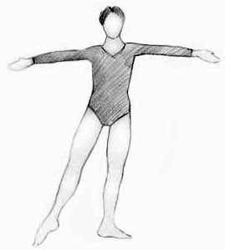
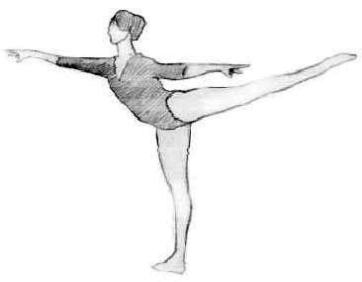

Rambert School of Ballet and Contemporary Dance welcomes applications from disabled people and offers places solely on the basis of potential and suitability for a career in the profession. You are encouraged to disclose any impairment or condition (for example, dyslexia, a physical, sensory or mental health condition) at the earliest opportunity so that we can endeavour to meet your needs at audition and during the course. All applicants who meet the criteria for entry to the School will be invited to audition.

Please email info@rambertschool.org.uk if you require an alternative format.

REFEREES

Below please list two persons whom the School may contact for a reference. One should be somebody familiar with your academic work (e.g. Head Teacher/Principal of your school/college), the other familiar with your dance training.

Title/Name ________________________________________ | Title/Name _________________________________________
Address ________________________________________ | Address _________________________________________
________________________________________ | _________________________________________
________________________________________ | _________________________________________
Postcode ____________ | Postcode ____________
Telephone ________________________________________ | Telephone __________________________________________
Email ________________________________________ | Email __________________________________________

PERSONAL STATEMENT
Please give a brief account of your achievements, ambitions and why you are applying for this course.

I declare that to the best of my knowledge all information given in this application is true, accurate and complete.

Signature of Applicant ___________________________________________________ Date ____________________

Signature of Parent/Guardian ______________________________________________ Date ____________________
(if applicant is under 18)
Rambert School of Ballet and Contemporary Dance
Monitoring Equal Access and Opportunity to Training

Name: _________________________________________ Proposed Starting Date: _________________

Please fill in the following monitoring information. Your response helps us to monitor our equal opportunities policy in the provision of training, and gives us valuable information about whether or not particular groups in the workforce have access to training. Please note that this is for monitoring purposes only and will not be used in any way to influence our decisions at audition or during the course.

Please tick (a)

1. I describe my ethnic origin as (tick one box only):

□ 10 White

□ 21 Black or Black British- Caribbean

□ 22 Black or Black British- African

□ 29 Other Black

□ 31 Asian or Asian British- Indian

□ 32 Asian or Asian British- Pakistani

□ 33 Asian or Asian British- Bangladeshi

□ 34 Chinese

□ 39 Other Asian

□ 41 Mixed – White and Black Caribbean

□ 42 Mixed – White and Black African

□ 43 Mixed – White and Asian

□ 49 Other Mixed background

□ 80 Other Ethnic background

□ 98 I do not wish to give this
information

2. “A person has a disability if s/he has a physical or mental impairment which has a substantial and long term adverse effect on her/his ability to carry out normal day to day activities. Impairment includes sensory impairment.”

Do you consider yourself to have a disability?

□ 00 No known disability

□ 01 A specific learning difficulty (eg dyslexia)

□ 02 Blind/partially sighted

□ 03 Deaf/hearing impairment

□ 04 Wheelchair user/mobility difficulties

□ 05 Personal care support

□ 06 Mental health difficulties

□ 07 Unseen disability, e.g. diabetes epilepsy, asthma

□ 08 Multiple disabilities

□ 10 Autistic spectrum disorder

□ 96 A disability not listed above

□ 97 I do not wish to give this information
Information for Disabled Students

Rambert School of Ballet and Contemporary Dance welcomes applications from disabled people and offers places solely on the basis of potential and suitability for a career in the profession. We encourage all students to visit the school before applying, to view classes and facilities and discuss any support or adjustments that may be required.

The Conservatoire for Dance and Drama (Rambert School of Ballet and Contemporary Dance is one of its eight affiliate schools) has produced a Support for Disabled Students Guide. This contains lots of interesting and useful information, with stories of eight successful disabled students on performing arts courses. To request a copy of the Guide, please contact staff in the Admin. office.

Buildings

Rambert School of Ballet and Contemporary Dance is based in Clifton Lodge, St Margaret’s Drive, with additional studios on the opposite side of the road.

The site has level access to the ground floor. There is an adapted toilet on the ground floor, and three further accessible toilets on the ground floor.

All the performances scheduled at Rambert School are accessible for wheelchair users. There are currently no signed performances, or hearing loops.

Student Productions / Off-site venues

Whilst most devising and rehearsing takes place at the Clifton Lodge site, some student production periods take place off-site at a variety of theatres. Access to these venues may vary, but where possible adjustments can be made to classes and performances held off-site.

Student Support

Rambert School is based is committed to supporting disabled students at all stages of the application process and within the course itself.

The Rambert School degree programme offers a range of support services. We can also help you to apply for the Disabled Students allowance where appropriate and arrange specialist dyslexIa support.

Admissions

All admission enquiries should be made in the first instance to: info@rambertschool.org.uk. If you wish to discuss disability issues further during the application and audition stage, or request information on applying for the Disabled Students Allowance (available to all disabled UK students) you should contact the School Secretary.

Specific Support for Dyslexic Students

If you know that you are dyslexic, we strongly encourage you to let us know as soon as possible. This will help us develop a Personal Learning Support Plan, and to assist UK based students to apply for the Disabled Students Allowance where you have not already done so.

In order to apply for a Disabled Students Allowance, dyslexic students will require a recent diagnostic assessment. Wherever possible this should be obtained from your secondary school or college before leaving. If this is not possible, Rambert School can arrange a diagnostic assessment. These assessments are fairly expensive (usually between £300 and £450) but students are eligible to apply for help towards the cost. You can discuss any related issues with the Student Support Co-Ordinator.

Programme Content and Learning Support Plans

Students who disclose an existing impairment or condition or become disabled during the course will be offered a Personal Learning Support Plan. This is an agreement developed between the student and the Head of Undergraduate Studies to identify support needs. With your consent, this information will be passed on to the relevant teaching staff in a confidential manner.

Requests for further information about the programme content or additional support needs will be referred to the Head of Undergraduate Studies.

